CPE301 – SPRING 2019

Design Assignment 3A

Student Name: Carlos D Zuniga

Student #: 2000783713

Student Email: zunigc2@unlv.nevada.edu

Primary Github address: https://github.com/cdaniel64/blassen/

Directory: DA3/DA3A

1. **COMPONENTS LIST AND CONNECTION BLOCK DIAGRAM w/ PINS**

List of Components used

ATMEGA328P, HITLEGO Shield, and HITLEGO FTDR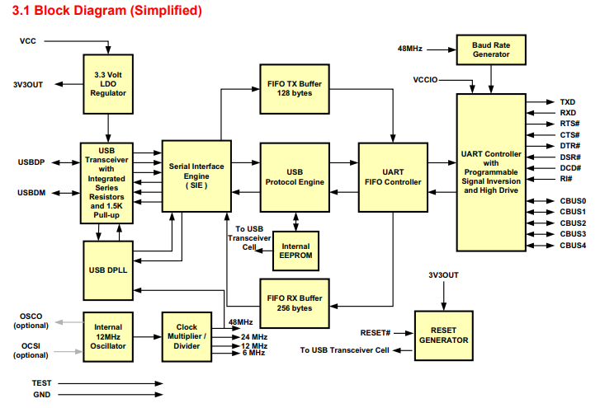

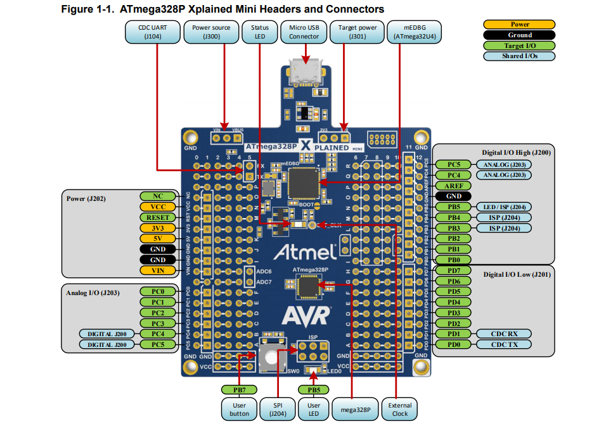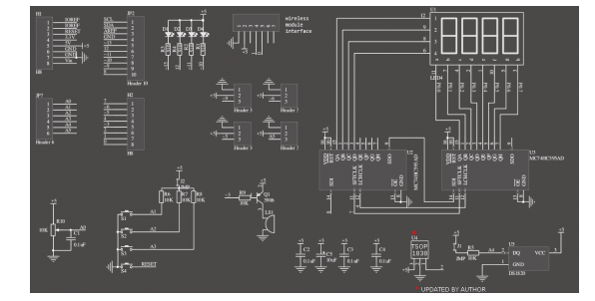

1. **INITIAL/MODIFIED/DEVELOPED CODE OF SINGLE TASK**

Task 1 Print characters, integer and floating number

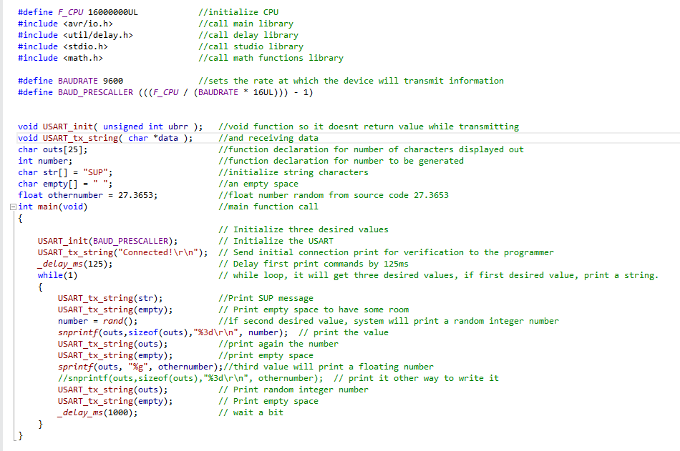

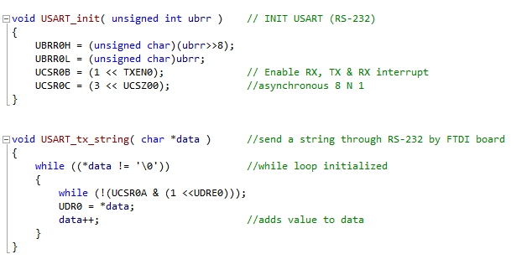

1. **SCHEMATICS**

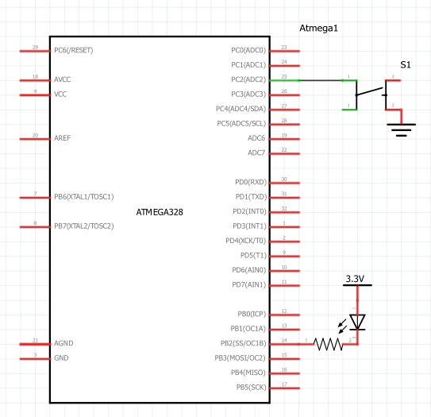

1. **SCREENSHOTS OF EACH TASK OUTPUT (ATMEL STUDIO OUTPUT)**

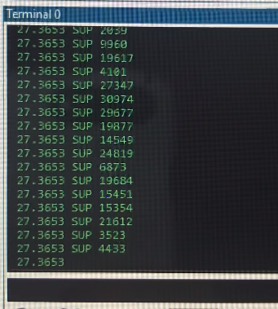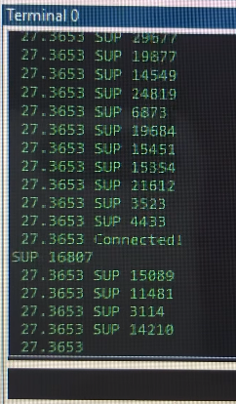

1. **VIDEO LINKS OF EACH DEMO**

<https://www.youtube.com/watch?v=vsYsP3QboeE>

1. **GITHUB LINK OF THIS DA**

<https://github.com/cdaniel64/blassen>

**Student Academic Misconduct Policy**

<http://studentconduct.unlv.edu/misconduct/policy.html>

“This assignment submission is my own, original work”.